**Capacitor Selection**

In our reference circuit, capacitor value is given as 0.1uf 400 V. We did some changes in reference circuit and we are still in range of capacitor so we can use that values for capacitor. According to this values we choose Ceramic disc capacitor.

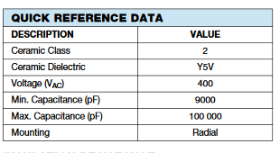

Figure X.

**Resistor Selection**

We have not specified resistance values. According to starting method, desired performance we are changing our resistance values. While choosing the resistance values, we should be careful about the current that passing through the resistor and power rating of the resistor.

In addition to these main components, we need a circuit board, heatsinks for the semiconductors, maybe a cooling unit. Moreover, we are planning to add a feedback unit. According to feedback, we need additional materials.